19 September 2024 postcard

And let the touring begin!

So far, I've kept up with transcribing my daily notes and triaging my photos for the blog, but that ends now. Once we're on a guided tour, whether with Tauck or Viking, I just take so many notes nad photos, and have so much less free time to work on them, that most of it just has to wait until I get home.

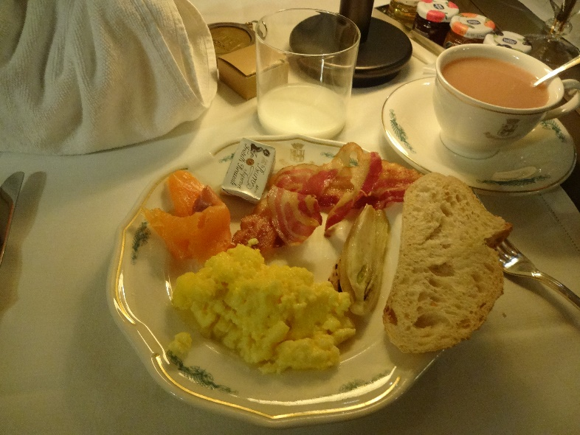I slept pretty well last night except when I got that wrong-number call from Tallahassee at 1:30 am. Breakfast started at 7 am. The coffee and tea set-up in the hotel room includes, *mirabile dictu,* a three-cup electric kettle, and the place is supplied with more towels (of three sizes and two textures, plus terry robes) than I could possibly use, so I was able to make myself a nice pot of tea, wrap it in a small terry towel and take it down to breakfast with me.

I had scrambled eggs (unsalted but otherwise perfect and easily corrected), bacon (it looked as though it would be limp and flabby but turned out to be crisp after all), bread and butter with smoked salmon on top, and a slice of grilled fennel. Nice. I wasn't in the mood for the extensive array of cakes and tarts.

David and I met in the lobby at 9:15 am with the rest of the group and were issued our new-model QuietVoxes, which are tiny, about half the size of my little digital camera. Our "small-group" tour includes only 24 guests, and we were split into two this morning for our walking tour, with two separate guides. For some reason, the other group got 14 people, and we got only 10. Our guide introduced himself as "Chessery," which I later learned is spelled "Cesare."

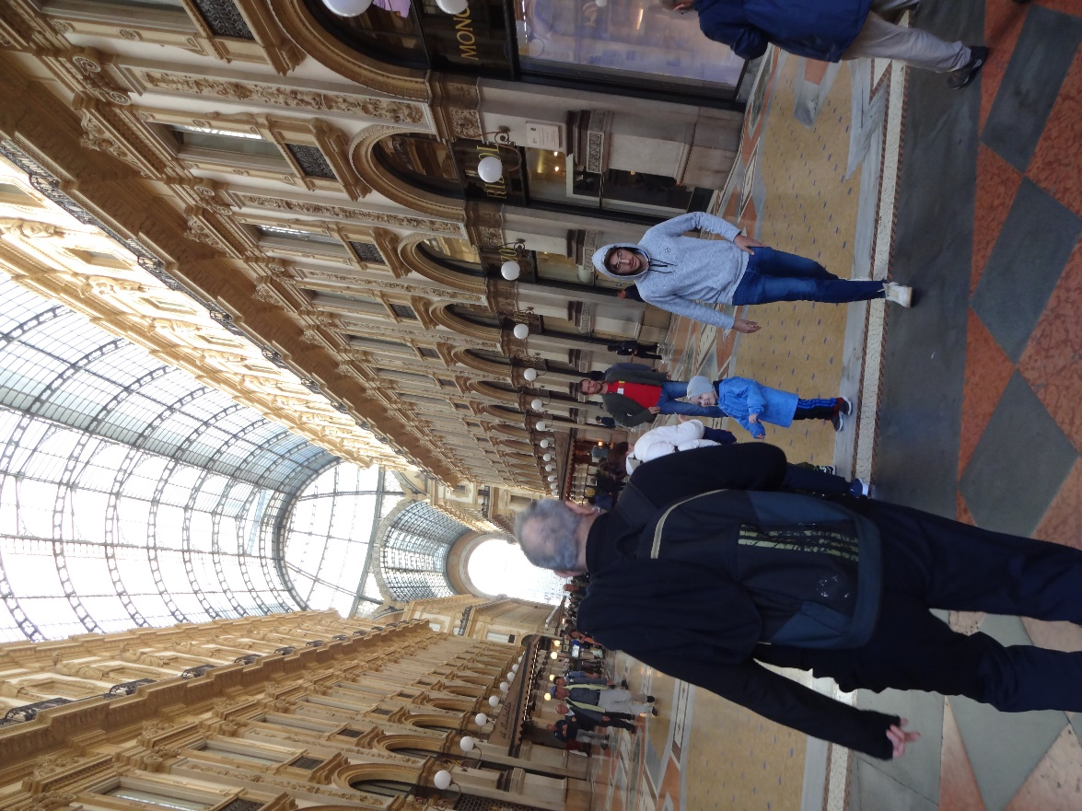We set off down Via Manzoni, being shown things all the way, stopped in the Piazza della Scala to admire the famous opera house (unfortunately, covered with scaffolding and scrim just now) and the monumental statue of Leonardo da Vinci, then continued to and through the Galleria Vittorio Emanuele II. It's the size, shape, and design of a cathedral, except that both the nave and the transcept are open at both ends, and the roof is steel-framed glass. It's the oldest shopping mall in the western world.

The galleria led us to the Piazza del Duomo, the cathedral square, Before visiting the cathedral, we walked around to the back entrance of the Palazzo Reale (the royal palace), now a museum, to see the current display of pages from the Atlantic Codex, 1119 pages of Leonardo's sketchbooks! They display a couple of dozen pages at a time and rotate them regularly.

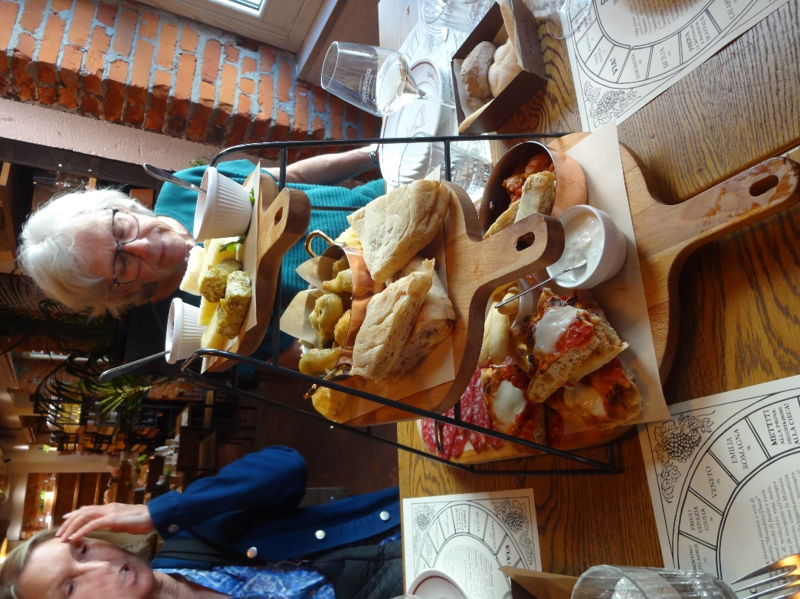Then it was time for lunch, so we walked around behind the cathedral to, yes, really, "Mistervino" for a lunch of finger foods, followed by a salad, then crispy almond cookies and custard. Coffee for those who wanted it.

After lunch, we had a guided tour of the cathedral before being turned loose for the rest of the day. We were issued tickets to the art-gallery side of the Palazzo Reale, in case we wanted to visit it on our own, but our feet were shot, so we walked back to the hotel.

For dinner, we were on our own. We tried for a couple of the restaurants recommnded by the tour director and the concierge, but it's fasion week in Milan, so everyplace was booked up. We would up having quite a nice dinner in the hotel's fancier restaurant, Don Carlos. After seafood, pasta, and bean soup for me, spaghetti and meatballs for David, and stuffed quail with pumpkin and sautéed chicory for both of us, we split this Napoleon of crisp pastry, dulche de leche, orange marmalade (!), hazelnut cream, and orange segments. Odd but tasty.

